BuzzFeed Marketing Challenge
Overview
BuzzFeed is one of the largest online publishers. Recent statistics show that the site gets 200+ million unique visitors each month with 60 percent of traffic coming from mobile. 50 percent of visitors are between 18-34 years old. 75 percent of BuzzFeed traffic comes from social media. For this group project, your task will be to identify a target market, create a BuzzFeed article or quiz that appeals to that market and reach that market using online promotion principles and targeted influencer outreach. Your success in reaching the market will partly be determined by the amount of views you generate (1,000 for full credit).
Learning Outcomes
The core of marketing is to create value and capture part of that value through the successful creation of products, services, and even digital content. Learning outcomes include:
- Experience with the product development process from idea generation to market testing to launch and promotion.
- Understanding of the power of network effects, network influencers, and consumer communities in accelerating the diffusion of communication.
- Understanding how core principles of consumption behavior, identity, emotion, and influence contribute to product development and marketing strategy.
Deliverables (1 per group, using the provided file format):
- Target Market & Content Ideas (Wednesday, November 8 – Email, before class)
  - Group 4 Market & Content.docx
- Promotion List (Monday, November 13 – Elearning, before class)
  - Group 4 Promotion List.docx (or .xlsx)
- Marketing Plan & Published Post URL (Wednesday, November 15 – Elearning, before class)
  - Group 4 Marketing Plan.docx
- Traffic Result (Wednesday, November 22 – Elearning, before class)
  - Group 4 Traffic Result.docx
- BuzzFeed Presentation (Wednesday, November 29 – Elearning, by 12 pm)
  - Group 4 Presentation.pptx
Target Market & Content Ideas – Due: Wednesday, November 8 by Email
Send an e-mail to scott.cowley@wmich.edu (copy all group members), including your idea for a target market and possible headlines you’re considering. Your target market is a group of people that cares about X or has some shared identity or interest. You can choose a broad or specific target market, but your target cannot be students/WMU-related and your idea must be unique and never been written on BuzzFeed before.
Promotion Plan – Due: Monday, November 13 in Elearning
Complete a BuzzFeed Outreach Plan (Excel example in Elearning). You must go beyond easy targets like friends and family (unless they are truly in the target market). You must include some topic-relevant people to persuade. Remember to be absolutely detailed and that having more options is better. Weigh the audience size of your target with the likelihood of actually getting your link distributed successfully.
BuzzFeed Content Requirement – Published Wednesday, November 15
- Sign up for a BuzzFeed community account as a team at http://www.buzzfeed.com/community. For ease of promoting as a group, pick a pseudonym/photo related to your topic. Ex. One group called themselves “BarStar” for their bar-related post.
- Review the guide for how/what to publish: http://www.buzzfeed.com/help
- Your post must be published before class on Wednesday, November 15
Format: Your content can be any length and format. You can use any combination of text, image, gif, video, etc. You can choose between making an article, list, quiz, poll, or checklist.
**Plagiarism and attribution are concerns for this assignment. Your content must be original (e.g., if your content is a list, no more than 20% of items should be taken from one source). It is critical that you give media attribution where possible. If you plagiarize or fail to give attribution, there will be problems.
Marketing Plan Requirements – Due: Wednesday, November 15 before class
Use the following template for your marketing plan. The finishing touch of your plan should be the URL where your post is published. Do not forget to include your URL.
Group 5  Marketing Plan | Title: “17 X-Men Valentines For The Superhero In Your Life”  URL: http://www.buzzfeed.com/keelyflaherty/xoxoxmen
Our inspiration for the post was… | One of the group members loved the most recent X-Men movie and have seen lots of friends excited about it; also knows a lot of X-Men sites.
Our target audience is… | Primary: People who like X-Men or have a significant other who likes X-Men  Secondary: Comic book lovers, people who hate X-Men, people who like cheesy humor
Our UVP is… | Multiple unique, funny, visual, X-men-related Valentines
4 alternative headlines we considered… | 17 of the Only X-Men Valentines You’ll Ever Need  Real Mutants Love These 17 X-Men Valentines  17 Hilarious X-Men Valentines  17 X-Men Valentines Guaranteed To Win Your Mutant Heart
The target market will share it because… | People want visual ways to express affection that aligns with their preferences; digital images make these easy to e-mail or link to.
They may not share it because… | It doesn’t have their favorite X-Men, they don’t like X-Men, they dislike pun-based humor, design quality wasn’t good enough
Our strategy to maximize content-market fit was… | We tested our headlines among a group of X-Men fans and chose the winner based on their feedback. We also solicited ideas for the Valentines from this group and got feedback on the final post. We added a few more at the end based on popular consensus. We also tried to put the best ones at the beginning of the post to grab attention. One group member showed it to the owner of an X-Men-related forum and got some helpful feedback on making the wording more crisp and said he would share the finished product on the forum.
Our strategy to reach 1,000 views is… | We created high quality content that we each feel comfortable sharing with our own personal networks. We plan to coordinate the publication time of our post so that we share it at the same time and have coordinated in advance to also share it in 2 target market Facebook groups. Together, the surge of traffic should get the post more visibility on BuzzFeed. Our plan is to ensure that at least 50% of our views are reached on Day 1, so that we can use other days to do outreach.

Promotion Ground Rules
You will have a full week (November 15-November 22) to execute your promotion plan and generate as many shares and views as possible (1,000 views for full credit). Pageviews can be counted through Wednesday, April 5.
- No PUBLIC click-begging (“everybody click this link!”), no mentioning that this is for a class or that you need 1,000 views, or that you’re on a deadline. Something along the lines of “I wrote this! Check it out!” is no problem, even though it’s a group product.
- No paid traffic
- No spamming people (sending the same message to everybody, repeatedly posting to the same forum, posting to completely irrelevant places). OK to share multiple times from your own social media account—switch up the messaging so you don’t look desperate.
- You MAY change your headline, content, or images during the campaign if you think it will help
Traffic Results – Due: Wednesday, November 22 by End of Day in Elearning
Submit a Word Document for your group through Elearning that includes your total visits for the campaign as well as screenshots (make them bigger than those below) to verify the results, including:
  - Cumulative Traffic Dashboard
  - Non-Cumulative Traffic Dashboard
  - Viral Traffic Referral Breakdown (showing all traffic sources)
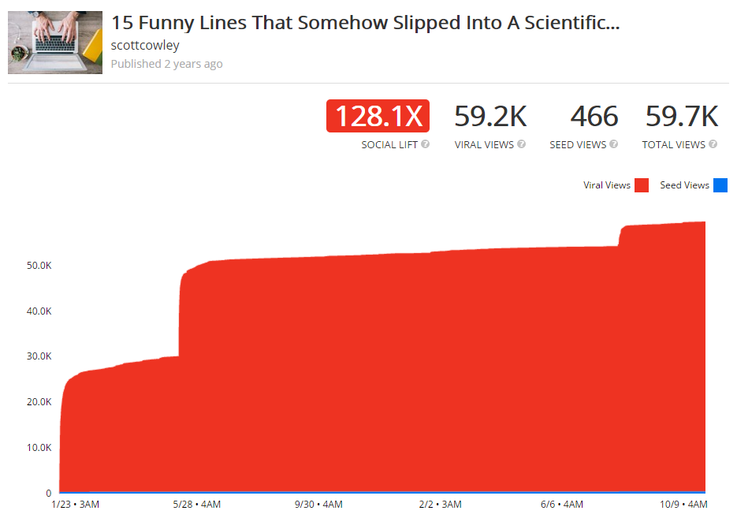
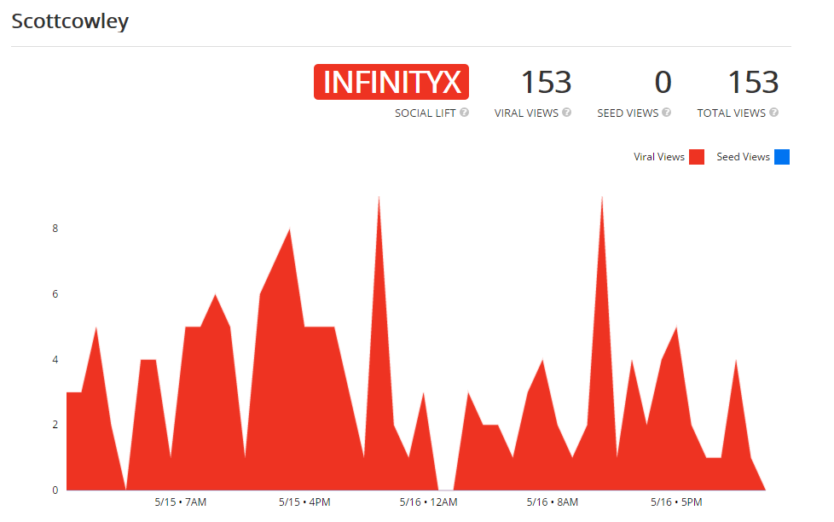
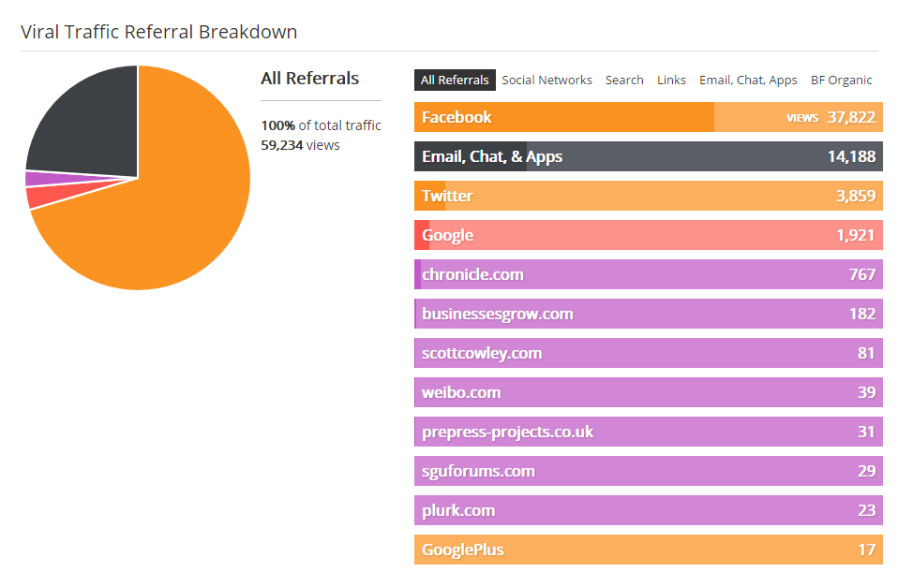

BuzzFeed PowerPoint Presentation – Due: Wednesday, November 29 by 12 pm in Elearning
Your group will present the story of your BuzzFeed post and campaign in class. All presentations will follow the Ignite presentation format, which means only 20 slides (including the title slide), each auto-advancing after 15 seconds, for a total of 5 minutes talk time. (In PPT, select all slides, then go to the “Transitions” ribbon, click the box under Advance Slide, After: 00:15.00; unclick “On Mouse-Click”)
Your presentation should include the following at minimum:
- BuzzFeed post and total visits (this should be near the beginning of the presentation)
- Content creation and strategy planning
- Execution of the promotion plan, outreach, and overall outcomes
- What went according to plan/not according to plan (positive or negative)
- How you adjusted your plan during the campaign
- One slide per team member for each person to talk about the most important thing(s) they learned from the experience
Everyone should talk approximately equal time. Remember to make this engaging interesting, and visual so we can all learn from different experiences.
Final Notes:
- You will be graded on your content, promotion plan, marketing plan, presentation, peer evaluation, and overall pageview performance. (You will get partial credit for pageviews less than 1,000 and 1 point extra credit for each 1,000 visits above 1K. Max. 5 EC points)
- Double-check everything for spelling and grammar before submitting to me or publishing online.
- Remember that you represent yourselves and the school in what you create and in your promotion tactics.
- If you have a question or want advice or feedback at any step of the process, take advantage of office hours or e-mail.
Media Resources:
- Giphy.com (GIF search)
- Pixabay.com (attribution-free stock photos)
- Images.google.com (use Creative Commons if at all possible; don’t use anything from Getty)
- Screenshots from YouTube videos are generally OK (always give attribution)
Content/Influencer Outreach Research Tools (in addition to searching the web and social media sites directly):
- Buzzsumo.com
- Followerwonk.com
- Use Google, Facebook, Twitter, Reddit, BuzzFeed for help in identifying relevant content ideas, influencers, forums, groups, and communities.

