BuzzFeed Valentine Assignment
Creative Content Requirements – Due: Monday, February 9
- Sign up for a BuzzFeed community account at http://www.buzzfeed.com/community and fill in your profile details to your comfort level.
- Review the guide for how/what to publish: http://www.buzzfeed.com/help/how_to_use
- Your post must be published by 5 pm on Monday, February 9
Topic: Your content and headline must be linked to Valentine’s Day in some way (love, dating, relationships, roses, chocolates, etc.) The word ‘love’ alone is insufficient, e.g., “6 Scientific Reasons People Love This Picture of a Cat.” Wondering whether your headline qualifies? Send me an e-mail.
You must also target a specific audience—a group of people who care about X. You can choose as broad or as specific a niche as you want, provided your target audience is not just everybody.
Format: Your content can be any length and format. You can use any combination of text, image, gif, video, etc. You can choose between making an article, list, quiz, poll, or checklist.
**Plagiarism and attribution are major concerns for this assignment. Your content must be original. It is critical that you give attribution where possible. If you plagiarize or submit something without attribution, there will be problems.
Marketing Plan Requirements – Due: Monday, February 9 by EOD
Submit your marketing plan and channel templates through Blackboard by 11:59 pm on Monday.
Marketing Plan | Title: “17 X-Men Valentines For The Superhero In Your Life”  URL: http://www.buzzfeed.com/keelyflaherty/xoxoxmen
My inspiration for the post was… | I loved the most recent X-Men movie and have seen lots of friends excited about it.
My target audience is… | Primary: People who like X-Men or have a significant other who likes X-Men  Secondary: Comic book lovers, people who hate X-Men, people who like cheesy humor
My USP is… | Multiple unique, funny, visual, X-men-related Valentines
They will find it via… | - Social media (Facebook, Twitter, Pinterest)  - Search engines (Optimizing for “x-men valentines”)  - Syndication (Comic-related websites, forums)
They will share it because… | People want visual ways to express affection that aligns with their preferences; digital images make these easy to e-mail or link to.
They may not share it because… | It doesn’t have their favorite X-Men, they don’t like X-Men, they dislike pun-based humor, design quality wasn’t good enough
My strategy to maximize product-market fit includes… | Examples of market research/market testing: audience research, headline generation, feedback from target market, identification of similar successful content, tools and data sources (Be specific)
An example of successful content targeting the same target audience is… | http://www.buzzfeed.com/perpetua/94-x-men-members-ranked-from-worst-to-best (34,042 total shares via Buzzsumo)

Complete a distribution channel planning table that aligns with your marketing plan and campaign objectives (it will be most useful to you as you go beyond familiar audiences like friends and family)
Distribution Platform/Channel | Specific Outreach Target? | Target Justification | Audience Size (est.) | Actual Traffic (est.)
Social Media (Twitter) | Chris Conroy (@dyfl) | Comic editor, shared X-men related humor | 2,300 | 60

Results Report Requirements – Due: Monday, February 16 by EOD
You will have a full week (February 9-16) to execute your promotion plan and generate as many shares and views as possible (1,000 views for full credit). Page views can be counted through Monday, February 16. Use the BuzzFeed analytics dashboard and your experience to assess your outcomes and generate insights to share.
Your report should include the following:
- Total visits since publishing (through Monday-Monday when the report is submitted)
- Paragraph executive summary of how the execution of the promotion plan went and overall outcomes
- Thoughtful description of:
  - What went most according to plan.
  - Anything you didn’t expect (positive or negative).
  - How you adjusted your plan during the campaign.
- Description of your most important takeaways about marketing strategy during the campaign. (Could be related to product-market fit, consumer behavior and influence, product lifecycle management, promotion and distribution, digital media, etc.). Use proper terminology.
- Screenshots of the results, including:
  - Traffic history chart
  - Referral breakdown
  - Search breakdown
  - Links breakdown

Screenshot Examples
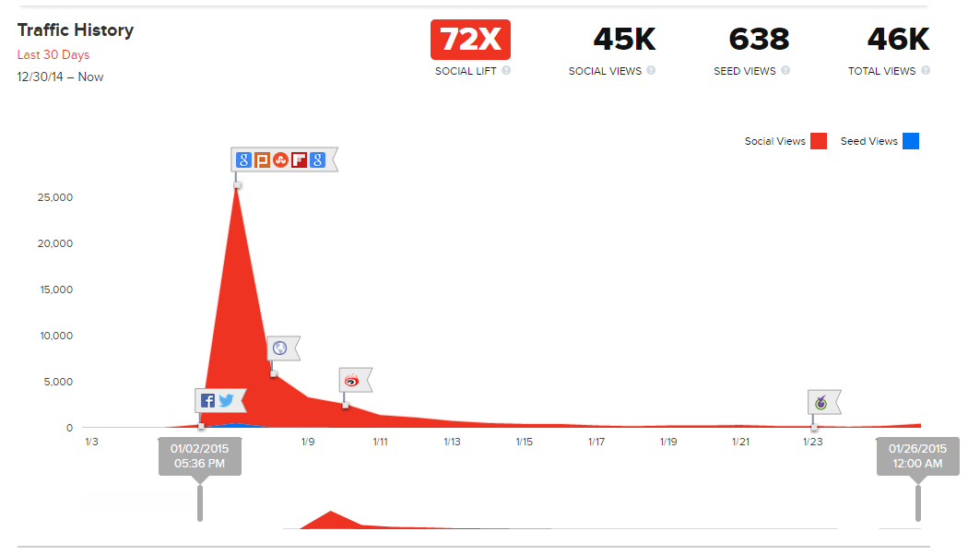
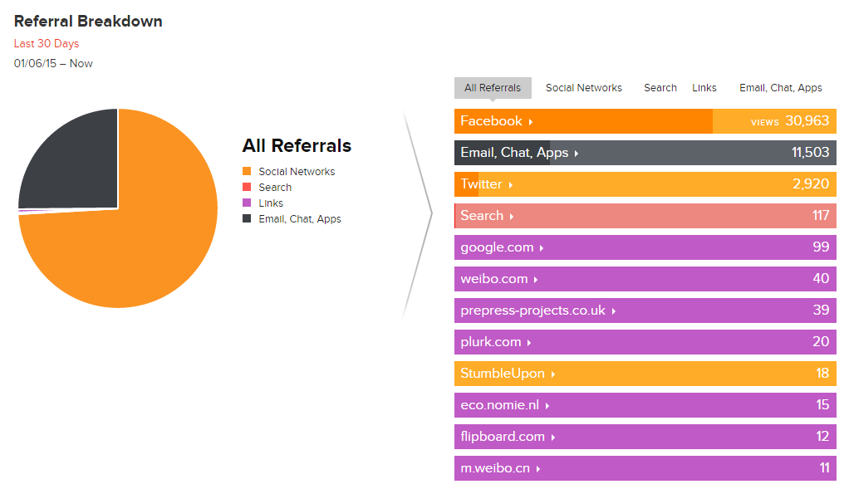
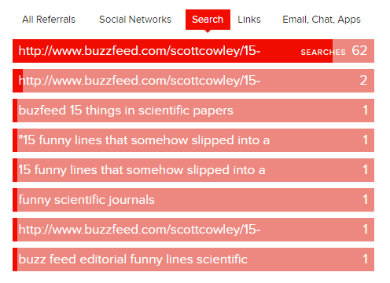
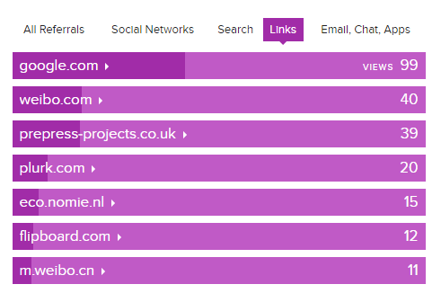

Additional Resources
Media:
- Pixabay.com (attribution-free stock photos)
- Compfight.com (Flickr Creative Commons photos – attribution required)
- Giphy.com (GIF search)
- Images.google.com (try to identify original source, if possible)
Content/Outreach Research Tools:
- Buzzsumo.com
- Opensiteexplorer.org
- Followerwonk.com

BuzzFeed Valentine Grading Sheet
Content (20 points)
Criteria | Points | Total | Comments
Content meets all textual, topical, and image requirements specified in the assignment sheet. | 20 |  | Deductions for the following: lack of media/media attribution, topic alignment, platform alignment, spelling and grammar, bad visual formatting, low creative effort

Marketing and Promotion Plan (20 points)
Criteria | Points | Total | Comments
Marketing plan meets all requirements, demonstrates strategic alignment, and critical thinking | 20

Results Report (20 points)
Criteria | Points | Total | Comments
Report meets all requirements, demonstrates critical thinking, and accurately presents the case outcomes. | 20

Performance (20 points)
Criteria | Points | Total | Comments
Traffic requirement  (1,000 total visits) | 20 |  | 1 point will be awarded for each 50 visits  (+1 EC point for each 10K visits, up to 50K)

